After the Storm: American Standard a Familiar Sight in
Hurricane Sandy Victims’ New Homes

When Hurricane Sandy tore through the Northeast on October 29, 2012, it hit some areas harder than others. One of the destruction epicenters was Union Beach, N.J., a town on the Raritan Bay where 300 homes had to be demolished due to flooding from up to 12 feet of water. In fact, 85 percent of homes in the borough had at least two feet of standing water in their first floor.

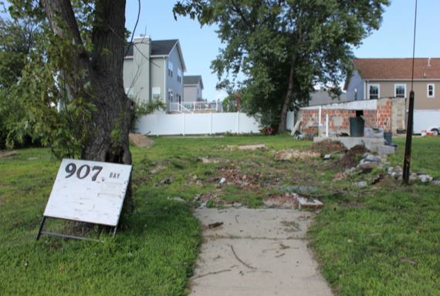
This residential lot in Union Beach, N.J. remains empty nearly two years after the house residing on it was destroyed by Hurricane Sandy. Fourteen similarly devastated homes were rebuilt using product donations from companies including plumbing manufacturer American Standard Brands.

The closely knit community came together in the wake of the storm, as residents, volunteers and borough officials collaborated to rebuild despite countless challenges — namely, getting the money needed to reconstruct in a durable, resilient and eco-friendly way.
-more-

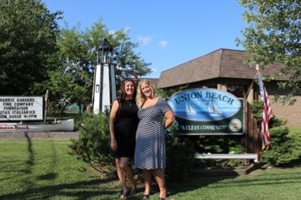
Small-town ties were the impetus behind one alliance that helped make rebuilding a bit easier and less costly. Shortly after Brenda Zimmerman stepped in to join the Rebuilding Union Beach team, the New Jersey native reconnected with her childhood friend Linda Bolger. Zimmerman told Bolger about her work with the recovery operation, sharing that the organization was looking for donations to construct 14 pre-fabricated, solar-powered homes. Once Bolger mentioned that she worked for American Standard Brands, a rewarding partnership was born between a devastated Garden State community and the 140-year old plumbing manufacturer that calls New Jersey its home.
Brenda Zimmerman (left) of Rebuilding Union Beach and Linda Bolger (right) of American Standard Brands attend a walk-through of homes that were part of the Rebuilding Union Beach project.
Bolger reported that American Standard executives didn’t hesitate when she told them about the opportunity to play a part in hurricane relief efforts. The company is headquartered in Piscataway, N.J., about 25 miles from the Bayshore town of Union Beach, and several of its employees were directly impacted by the storm's destructive force.

A New Start in Union Beach, N.J.
Rebuilding Union Beach is being funded through a $1.67 million grant from the Hurricane Sandy New Jersey Relief Fund and a $770,000 grant from the Robin Hood Foundation, among other donations. Residents whose homes were completely destroyed could qualify for the program and participated in a thorough financial review process.
More than 75 organizations, companies and individuals donated products and services to rebuild the homes. Thanks to the partnership between Zimmerman and Bolger, American Standard is proud to be one of them. After the women reconnected, their respective teams sprang into action to review the modular home plans for each house and determine which products would fit best in the differing applications.
-more-

“We tried to choose our step-up, mid-range products,” Bolger said, adding that she was pleased residents could enjoy a variety of top-quality American Standard products in their new homes. “Everyone has been able to put a little of their own taste to it.”
Donations stretched grant money dollars
While grants helped to support the construction projects, product and material donations were instrumental in offsetting production costs so that donation dollars could stretch to help more people. “Getting a substantial donation like this is very valuable,” Zimmerman said of the American Standard products contributed for bathrooms and kitchens.
Scott Lauer, a consultant on the project, said that American Standard’s donation of plumbing fixtures for the homes enabled the borough to earmark “substantial funding to put towards another home.” Plus, the well-known, reliable "American Standard" name on toilets, sinks, faucets and tubs gave an extra degree of security to the Union Beach residents.
“It’s very helpful to be able to offer the homeowners products that are familiar [to them],” he said. “There’s a comfort level and confidence in using trusted, recognizable brands.”
Jennifer Maier, the borough administrator and founder of Rebuilding Union Beach, has a background in architecture and regularly used American Standard products in the homes she designed before her role as a municipal employee. For her, being able to have the brand on board was a bonus.
“They are the standard in the industry,” she said, adding that the products are known for consistent quality. “That’s what I think of when I think of American Standard.”

Plumbing with a personal touch
In addition to kitchen and bathroom sinks, faucets, shower stalls, bathtubs, and other hardware products, American Standard was able to donate a Gelcoat walk-in bathtub for Catherine Baird. The Fourth Street home of this disabled Union Beach resident had survived many previous storms since it was built during the 1920s. Without this specialized bathing product, Baird would have had a traditional bathtub and shower that would be difficult to use.

-more-

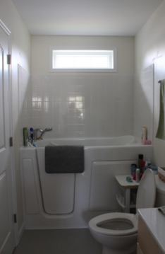
“It makes it easier for me because I have a problem getting in and out of the tub,” Baird said. Her new bathtub is made from fiberglass-reinforced gelcoat and has a large walk-in door, built-in chair-height seat for comfort, and textured floor for added safety. Along with her husband ― who served as a Union Beach firefighter for decades ― she was pleased with the upgrade that allows for a safe and relaxing bathing experience in their new home.
“That was really the pride of all of this,” Zimmerman commented on the walk-in bath, adding that being able to get products tailored for residents’ needs gave the project a personal touch.
The Bairds were relieved to hear that their new fixtures would be American Standard products. Residents had limited options when it came to designing and furnishing their new homes, so hearing the name of a dependable brand was welcome news.
The Bairds' new bathroom features an American Standard Gelcoat walk-in tub, Cadet PRO high efficiency toilet and other furnishings that were donated to reconstruct the home.
The Baird family’s original home contained American Standard fixtures, so being able to move into a new home with the familiar features created a sense of comfort after numerous months of uncertainty.
The Bairds' bathrooms include Cadet PRO high efficiency toilets that use only 1.28 gallons per flush (gpf) and are WaterSense-certified to provide high performance while using 20 percent less water than traditional toilets. Also included are the clean, soft lines of American Standard Colony Soft centerset faucets, which are engineered to look beautiful and function flawlessly with worry-free, drip-free performance. Like all American Standard bathroom sink faucets, the Colony Soft line uses only 1.5 gallons per minute (gpm) and is WaterSense-certified for using 32 percent less water than standard 2.2 gpm styles, without sacrificing performance.
-more-

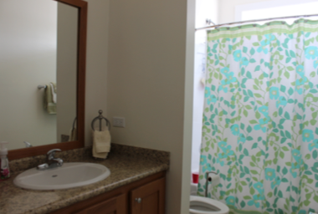
“It is extremely rewarding to see our products making a difference in people’s lives,” American Standard’s Bolger added, after touring the couple’s rebuilt home.

Coming home to a familiar name
Union Beach resident Jadwiga Parzych was equally excited about her new bathtub, but for different reasons. Just two weeks before the storm hit her nearly 100-year-old home on Eighth Street, she had completed a high-end bathroom renovation that included an imported bathtub. She soaked in it only once before the storm destroyed her entire home.
The new bathroom in the Parzych home in Union Beach, N.J. ― rebuilt after being destroyed during Hurricane Sandy ― now includes an AcryLUX bath/shower wall set, Cadet PRO high efficiency toilet, Aqualyn countertop sink and Colony Soft lavatory faucet, all donated by American Standard.
While watching her dream renovation go down the drain was hard, she was pleased and comforted to hear that American Standard products would be installed in her newly rebuilt house. Her reconstructed bathroom now boasts a durable, fiberglass-reinforced AcryLUX bathtub and shower wall surround with by-pass bath doors made from tempered glass in a rain privacy pattern.
The bathroom isn’t the only hot spot — a new modern Prevoir drop-in double-bowl sink in brushed stainless steel and Quince high arc, pull-down kitchen faucet with side spray in polished chrome have made cooking and cleaning in the kitchen much easier for Parzych.

Celebrating home
Over on Florence Avenue, the same kitchen sink and faucet combination has been a godsend for Diana Hoffman. “I absolutely love this,” Hoffman said, admiring her new kitchen. Her previous fixtures were also made by American Standard, so she was happy to hear she could enjoy the same high quality features in her rebuilt home.

-more-

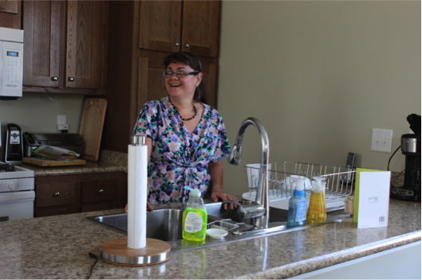
Both of her home’s bathrooms now feature the American Standard AcryLUX bathtub and shower wall surround with its easy-to-clean walls and beautiful high-gloss shine. Plus, the new Cadet PRO toilets in the Hoffmans' home provide optimum performance with PowerWash bowl cleaning technology and the unique EverClean permanent finish that helps toilets stay cleaner, longer.
Union Beach resident Diana Hoffman enjoys her new kitchen equipped with an American Standard Prevoir stainless steel sink and Quince high arc, pull-down faucet.

“I like the idea of having everything in one. It's convenient,” Hoffman said of the Colony Soft shower faucet and controls that feature the exclusive American Standard TRIMendous interchangeable trim and valves, lifetime drip-free performance and hot limit safety stops to protect from accidental scalding.
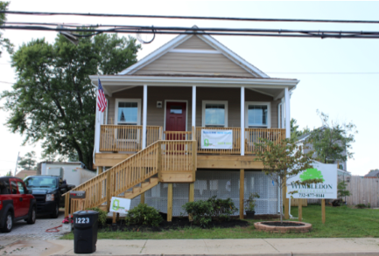
All of the homes are raised 8-17 feet above ground on pilings so they can stand up to future floods. Zimmerman said that’s been a challenge for the town because previously most residents communicated with each other from the comfort of their front porches. For the Hoffman family, however, the new height was a bonus. After moving into their home on July 3, 2014, they were able to take in views of Fourth of July fireworks from several neighboring towns the very next night.
The new Hoffman residence, which was rebuilt after Hurricane Sandy, features two bathrooms outfitted with American Standard Cadet PRO high efficiency toilets, Colony Soft faucets and Aqualyn lavatories, all donated by the New Jersey-headquartered plumbing manufacturer.

-more-

‘Happy to be home’
Hoffman said that her new kitchen, complete with American Standard fixtures, is the heart of her home — a place that she is beyond grateful to have, even though it cannot replace her original home.
“The donation made a huge difference,” said project consultant Lauer of the American Standard products. As for the residents in town, they will soon mark the two-year anniversary of this natural disaster, Hurricane Sandy. While much was lost, they have been able to gain something back and move forward with their lives.
“They’re so happy to be home,” Lauer said.

Cadet®, Colony® Soft, Aqualyn®, AcryLUX®, PowerWash®, EverClean® and TRIMendous® are registered trademarks of American Standard Brands.
Prevoir™ is a trademark of American Standard Brands.
WaterSense® is a registered trademark of the U.S. Environmental Protection Agency (EPA).

###

